SWA Science & Technology Assessment Team
(13 May 2003)

Activity: Material Assessments, 1-227th Aviation Battalion, 1st Cavalry Division

Location: Camp Doha

Participants:

MAJ Robert Johnston (AMC FAST)
CW5 Lance Mackalaney (AH-64D Standardization Instructor Pilot)
CW3 Troy Templeton (AVUM Production Control OIC) – troy.david.templeton@us.army.mil
SFC Mike Bonney (AVUM, Production Control NCOIC)

Background: 1-227th is an AH-64D Longbow equipped unit. It encountered fierce combat consisting of intense enemy small arms and RPG fire. As a result, this unit had one AH-64D shot down. All Battalion aircraft, except one, had battle damage. The unit’s aircraft had an average of 15 to 20 bullet holes each. CW3 Templeton’s aircraft had 29 bullet holes. Upon return from the mission, all of the aircraft were not flyable and consequently were non-mission capable (NMC). Within 24 hours, the unit had 2 aircraft mission ready. Within 96 hours, the unit had 10 to 12 mission ready. All of the battle-damaged aircraft were flyable within 30 days. Despite the high degree of battle damage, the pilots were very confident in the Apache and its’ survivability. CW3 Templeton said there is no other aircraft he would have rather have been flying while being inundated with the volume of enemy fire that he experienced.

Move Results:

- Auxiliary Fuel Tanks: Auxiliary fuel tanks were not flown on combat missions.

Shoot Results:

- 2.75 inch Rocket Pod fires: Two rocket pods caught fire during the fight and were subsequently jettisoned.

- 2.75 inch Rockets, Flechettes: The unit had difficulty firing Flechette rockets. Flechette rockets would only fire if illumination or smoke was selected as the type of rocket to fire. Consequently, Flechettes were not fired.

- 2.75 inch Rocket Pod Dust Covers: Crews requested a dust cover for installation with MPSM rockets installed. If the remote fusing port in the rocket pod did not have an umbilical connected to it, it would become unusable due to sand build up inside. Current rocket pod covers will not fit with MPSM rockets installed. Additionally, the crews requested a cover that could be installed on the aft portion of the rocket pod.

- RF Missile: Not many RF missiles were fired (1 for sure and it hit). After the fight, they said they would have carried more RF missiles rather than the laser type. They preferred the fire and forget type RF system. An RF missile would have allowed them more time to maneuver. The Laser missiles they fired exposed them to ground fire longer because of the required laser terminal guidance. They were able to fire the RF missile with a laser designation. The system required about 3 seconds for the RF missile to acquire needed data before launch, but once launched, the pilots were done and could maneuver to minimize or avoid ground fire. The pilots prefer to have this time reduced to 1 second or less.

- 30mm Chain Gun: Overall, the pilots thought that the 30mm chain gun worked great. “The 30mm was the best weapon on the aircraft; it was super accurate and provided rapid fire.” However, a suspected bad lot of ammunition caused many system failures and pilots started to use the system only in self defense for fear of having a system malfunction. According to the pilots, the unit received a restricted lot of ammunition, which was restricted to war time use only. This ammunition lot caused about 50% of the aircraft to return with rounds stuck inside the barrel. The unit had to replace 3 receivers and 3 barrels. Additionally, many guns failed because of evasive maneuvers to avoid ground fire while gunners were firing the 30mm system. It was suspected that moving in and out of weapons constraints caused the failures. As the guns would move into and out of constraints and the gun would start and stop firing accordingly. This caused system not to complete a full firing cycle, which led to failures.

- Airsave: Airsave is too bulky. Crew space inside the cockpit is limited and currently, pilots are required to wear too much equipment. They would prefer not to wear the JSLIST.

- Pilot Displays: Crews like the stick map on TSD. They said it was “awesome”. However, they would like to have the capability to edit it on the fly.

- DTC: Pilots cannot directly store complete mission profiles on the DTC. They are limited to the number of control features and are not able to load all of the ground maneuver graphics. This limits the compatibility between air and ground units. Crews need to be able to load more control features more so they can load all of the ground maneuver graphics.

- Cockpit Management: AH-64D cockpit management was good. Pilots said they could “fly, get shot at, maneuver, and still pull up needed pages.”

- MPD pages: Pilots would like to duplicate the function that allows them to return directly to a page displayed prior to using the Z-axis symbology button to display the flight data page. Pilots would like to have another button that acts like the Z-axis symbology button to command the right MPD to similarly display the flight page. Additionally, the pilots would like to eliminate the 10-minute time limit to page back to the original page. They would prefer to return to the original page at any time. This would effectively provide the pilots 4 pages to manipulate during flight with the push of one or two buttons.

- RFI & APR-39: Pilots trusted the data coming from the RFI and thought the system worked great. However, they did not trust the APR-39, radar-warning receiver. The APR-39 frequently failed different channels and gave too many false warnings. Essentially, pilots ignored the data from the APR-39.

Communicate Results:

- Supply Communication: During operations, the supply communications were non-functional. The unit requested satellite phones to communicate with item managers.

Sustain Results:

- Battle Damage, Communication Interface Unit (CIU): Pilots request eliminating this single point failure. One aircraft took a small arms round through the CIU. As a result, the aircraft lost complete communications. Neither pilots could communicate via ICS nor could they communicate externally with any radio.

- Battle Damage, Wire Bundle: Pilots request eliminating this single point failure. One aircraft took a small arms round through the wire bundle located above the left main landing gear (see figures 1, 2 and 3). These photos were taken after repair and figures 1 & 2 are shown to orient the reader as to the location of the wire bundle in question. Figure 3 also shows a battle damage repair on the landing gear strut where the small arms round hit first before damaging the wire bundle. The repair looks like a small white scuff (see red arrow). As a result of this round, the aircraft lost all electrical power except for back-up DC power. After many attempts and several minutes, the pilot was able to reset and gain power from one generator.

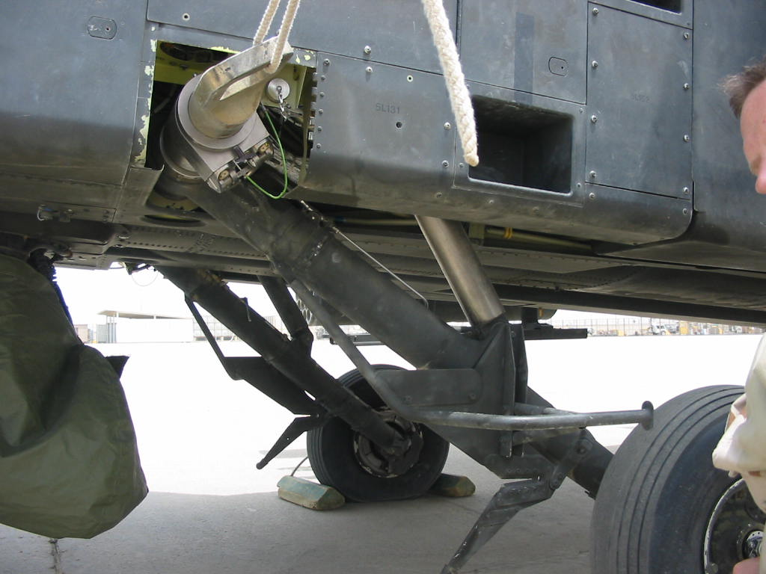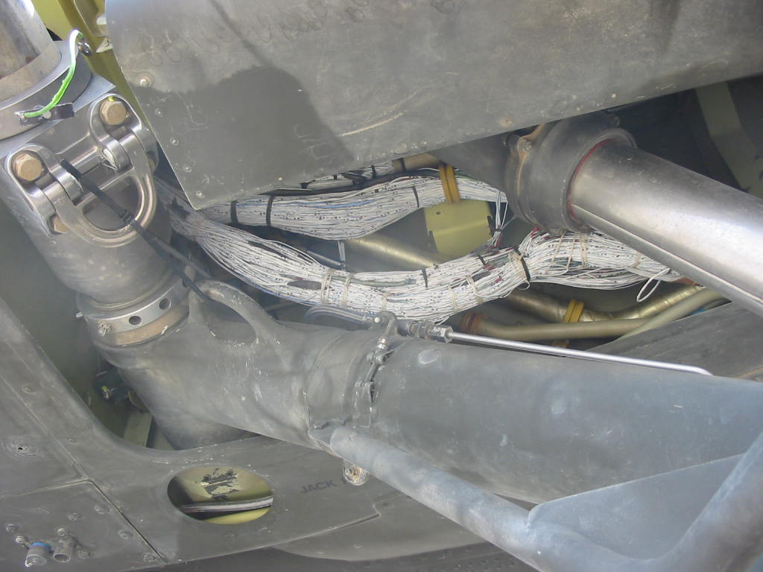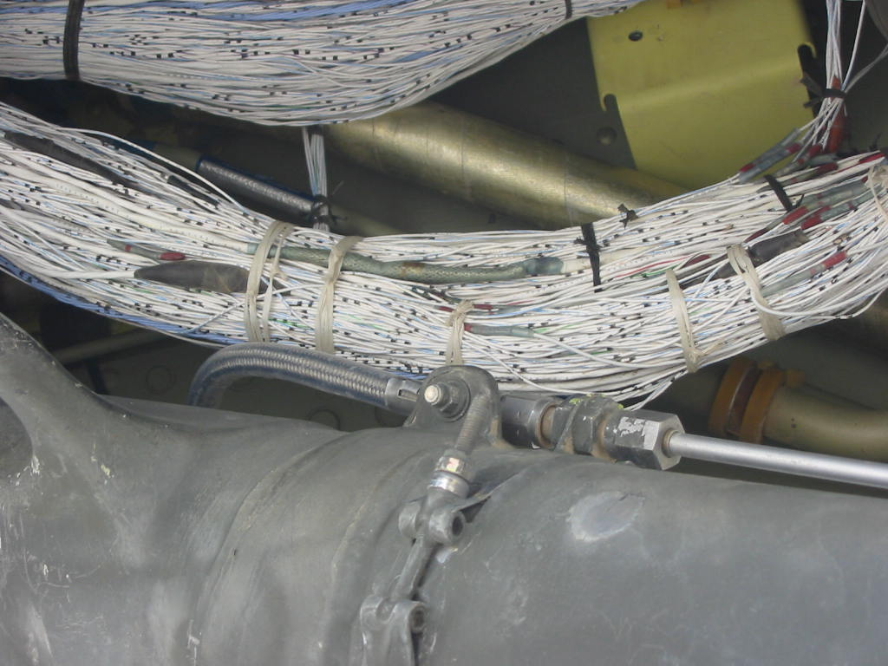

Figure 1 Figure 2 Figure 3

- Battle Damage, Protective Kevlar Tray: The Kevlar tray under the hydraulic lines in the tail boom area protected the hydraulic lines well. One small arms round directly impacted the kevlar tray. The hydraulic line was only slightly bent (see figures 4 and 5).

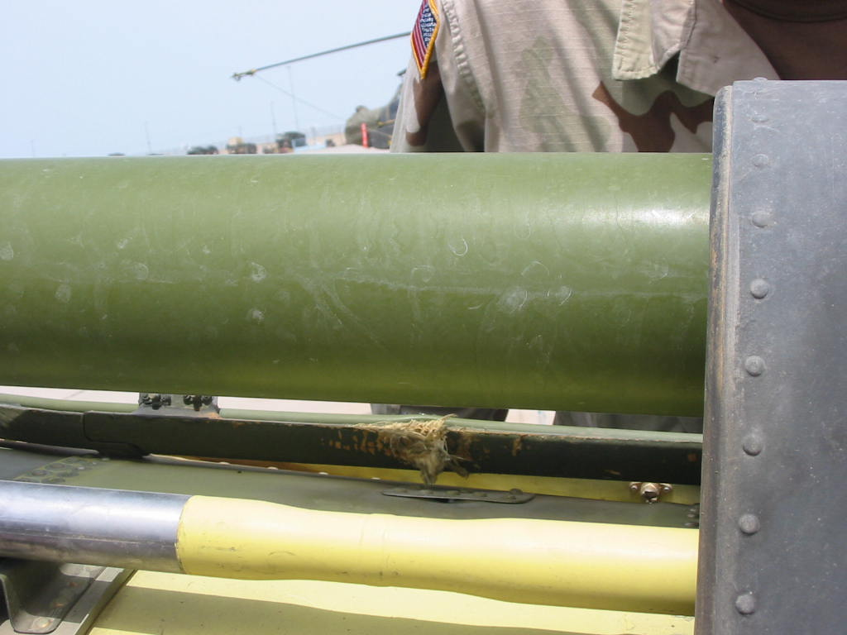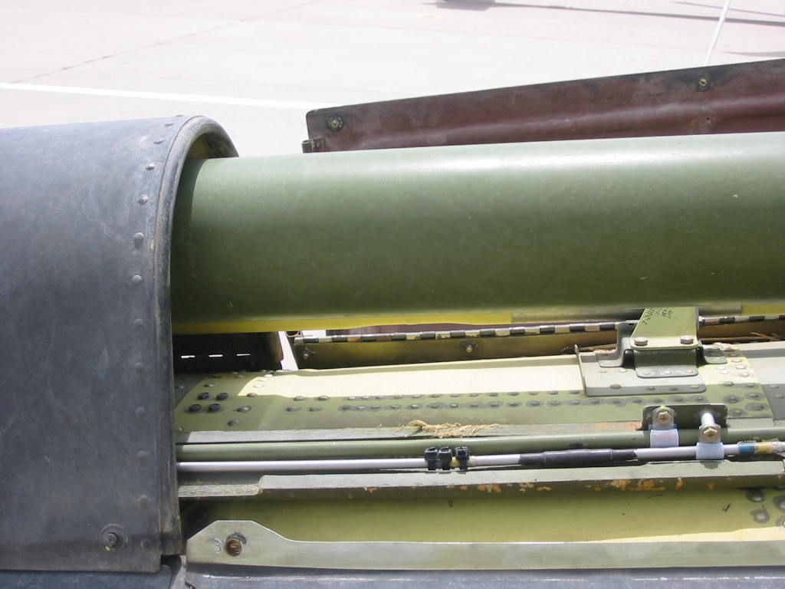

Figure 4 Figure 5

- Battle Damage, Tail Rotor Drive Shaft: Tail rotor drive shafts on several aircraft took small arms hits. No excessive vibration or other concerns were noted. Four drive shafts were replaced.

- Battle Damage, ECS line: Field expedient repair was made on the ECS line in the left FAB (see figure 6). Note the bullet hole on the bottom of the FAB and the battle damage repair made above the field expedient ECS line repair.

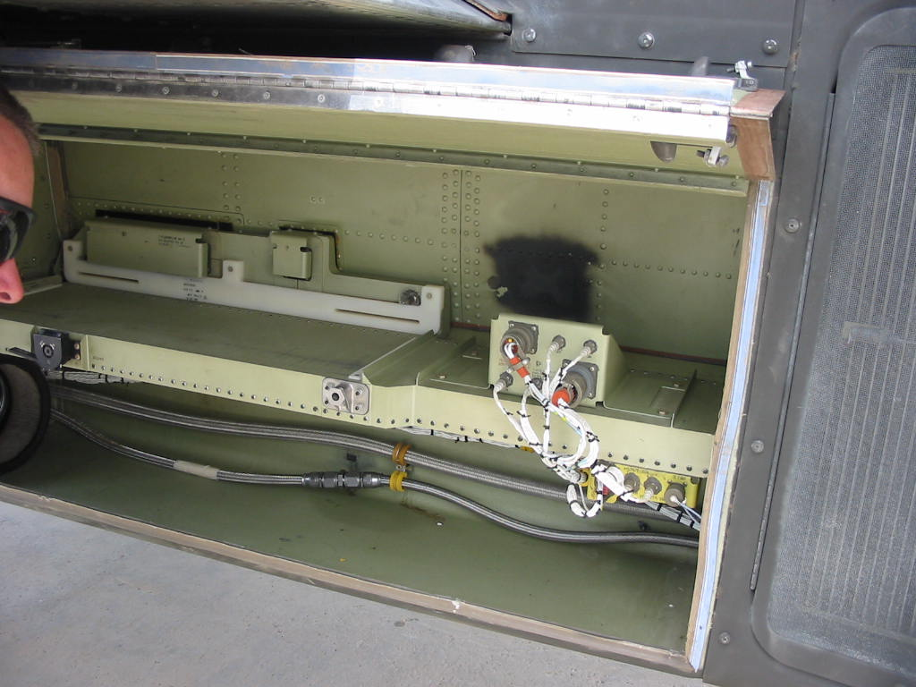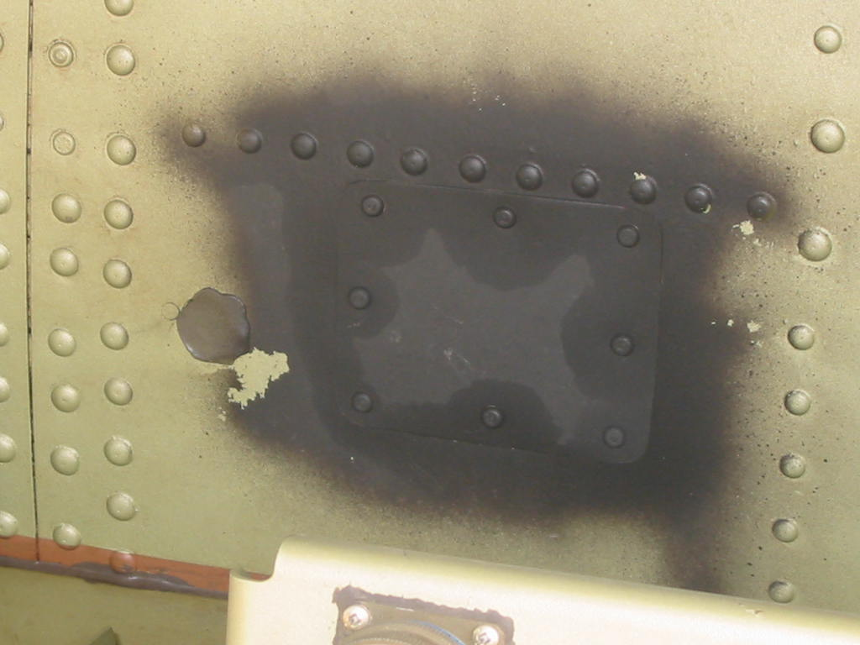

Figure 6 Figure 7
- Battle Damage Repair (BDR): Maintenance personnel were satisfied with BDR repair instructions. No issues or concerns were mentioned about the BDR book. Battle damage repair was performed according to the Apache BDR book with the AH-64D supplement. To show the magnitude and rate of repairs, the maintenance crew conducted, on average, 70 small arms hole repairs per day until all repairs were completed. Figure 7 shows a typical bullet hole repair.

- Battle Damage, General Electric Engine: Pilots were very satisfied with the durability of the GE engine. After the fight, small arms bullet holes were found in the engine hot section of the GE engine. Health Indication Test (HIT) checks were completed and results showed no degradation in performance. Three engines in total were replaced. There was a negative comment about the engine oil cooler because of an engine fire that resulted from small arms fire hitting a Number 1 (left side) engine’s oil cooler. The fuel to oil heat transfer within the cooler is an efficient method to cool the oil, but increases the likely hood of fire due to battle damage.

- Battle Damage, Fuel Cells: Three forward and four aft fuel cells were replaced due to battle damage. The primary reason for replacing the fuel cells was fuel leakage. All the fuel cells that received bullet holes on or near cell seams developed leaks and the system did not self seal. All the bullet holes in the center of the tank self sealed well.

- Battle Damage, Rotor Blades: Thirteen main rotor and three tail rotor blades were replaced. 34 main and tail rotor blades were repaired.

- Battle Damage, Fire Control Radar (FCR): Only two FCRs received battle damage. One required the dome to be replaced. One received a bullet hole through a forward lifting point. No other damage resulted.

- Battle Damage, Airframe Interface Assembly (AIA): Crews were not happy with the vulnerability of the AIA. At least one aircraft had a single round hit and completely disable the AIA, which resulted in unusable TADS and PNVS. Pilots did not like the idea that a single round could disable the aircraft to the point it was just a “high speed radio”. The pilots recommended installing some sort of ballistic shielding in the form of a kevlar blanket.

- Stabilator: Pilots credited a minimal amount of battle damage to the tail rotor due to the stabilator. Numerous small arms bullet holes were found in the stabilators. Pilots requested additional material be applied to the stabilator to make it more robust and further increase the protection given to the tail rotor. Materials suggested were foam or fiberglass.

- Ammunition Magazine / Robinson Tank lifting device: The unit needed a device to remove ammunition magazines and Robinson Internal Tanks. Five aircraft were unable to download 30mm rounds due to hydraulic, electrical failures, or damage to magazine from small arms rounds. Five aircraft had utility hydraulic problems and two aircraft had electrical failures. The maintenance personnel found it extremely difficult, and hazardous, to manually remove loaded magazines from the aircraft.

- Auxiliary Power Unit (APU): The unit liked the APU filter. However, improvements are requested. First, the filter worked well in “normal” sand, but there was sand encountered in Southern Iraq that had talcum powder like consistency. Sand at the National Training Center (NTC) or Udari, was categorized as “normal” sand. The talcum like sand would quickly and completely clog the filter. Additionally, the oil substance used on the filter increased the rate the sand clogged the filter. Under these harsh conditions, the unit would remove the filter and shake it out prior to every flight. Every 10 to 25 hours the filter would require chemical cleaning with “K&N” cleaner. Second, because of the frequent access required to remove and clean the filter, the unit requested an access door be added to the APU cover. Figure 8 shows where the APU filter is located on the APU. Figure 9 shows the desired location for the access panel on the APU cover. Finally, probably due to the sand environment, the unit experienced a high rate of APU power turbine failures.

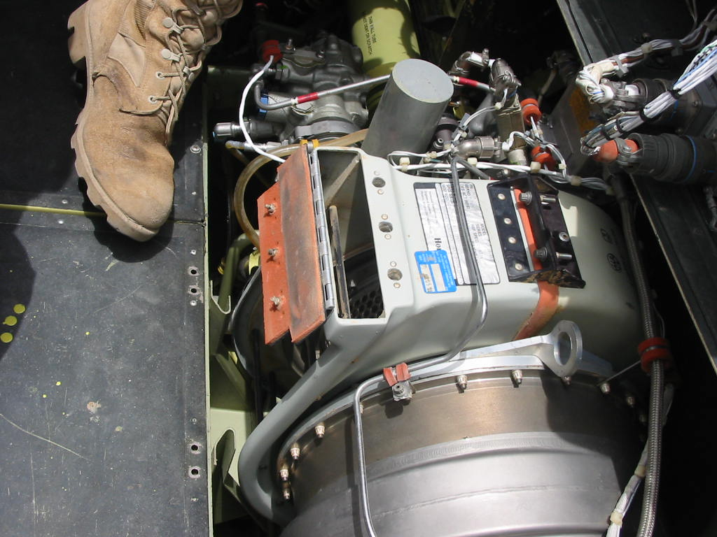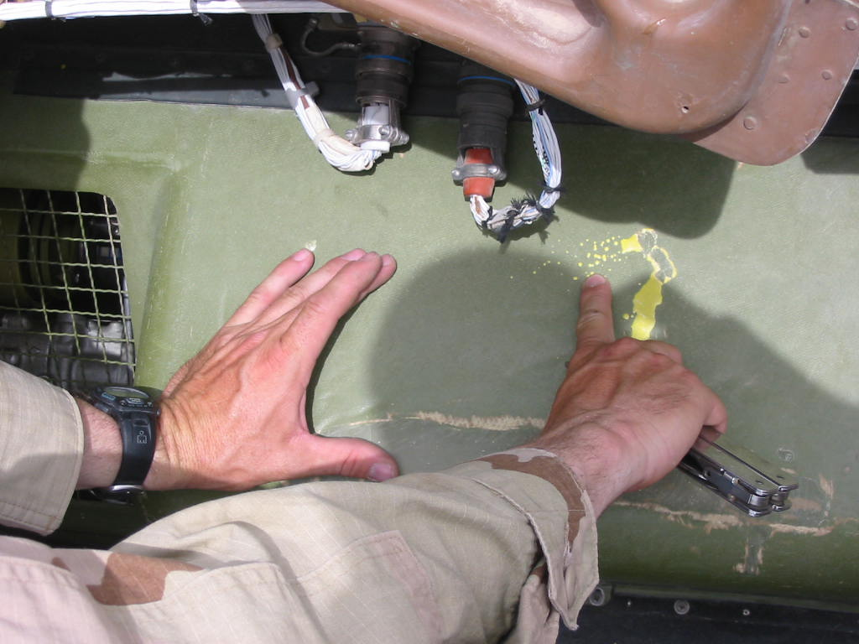

Figure 8: APU Filter Slot Figure 9: Desired Location for Access Door

- ALQ-144 IR Countermeasure: The unit had a very high failure rate on the ALQ-144. On average, 33% would fail after every multi aircraft flight. The 7-159th aviation intermediate maintenance (AVIM) company had 6 spares that were used extensively while the failed components were being fixed. Typically, the AVIM unit would have to replace either the high speed bearing or the low speed bearing and could repair the component within 1 day. To help reduce the failure rate, CECOM authorized a modified operating procedure. During aircraft run-up and system checkout, the ALQ-144 would be turned on and allowed to run a self test. Once the self test was successfully completed, but prior to take-off, the system would be turned off without allowing for the normal 10 minute cool down period. Once in flight, the system would then be turned on. Alternately, the system would be turned off prior to shut down. During operations using this procedure, only one core heating element failed. Additionally, the unit built hard covers to protect the system from blowing rocks and other debris that could potentially damage the external fragile glass (see figures 10 and 11). Figure 11 shows the inside padding used to protect the ALQ-144.

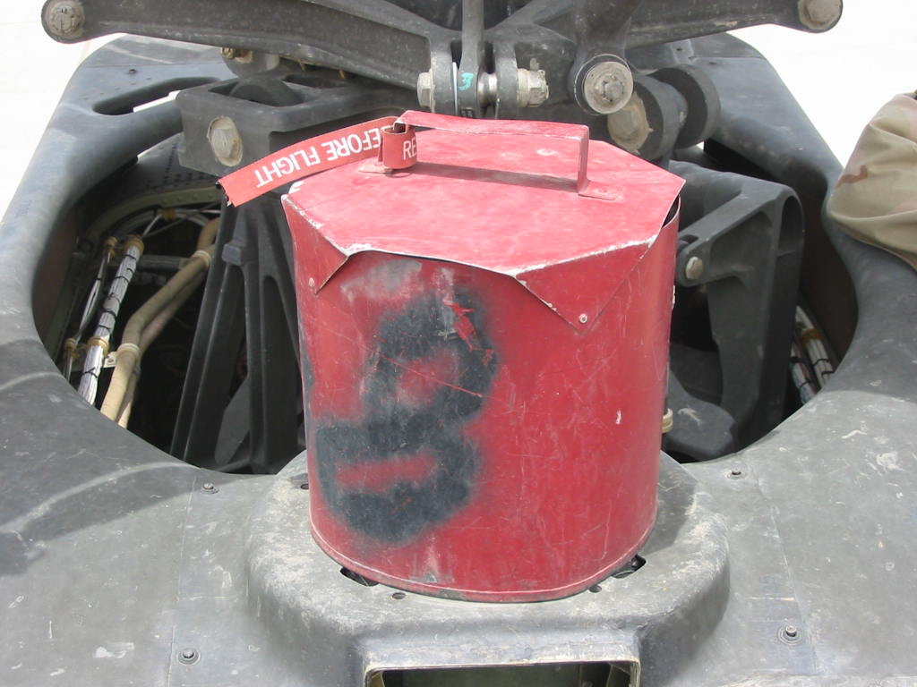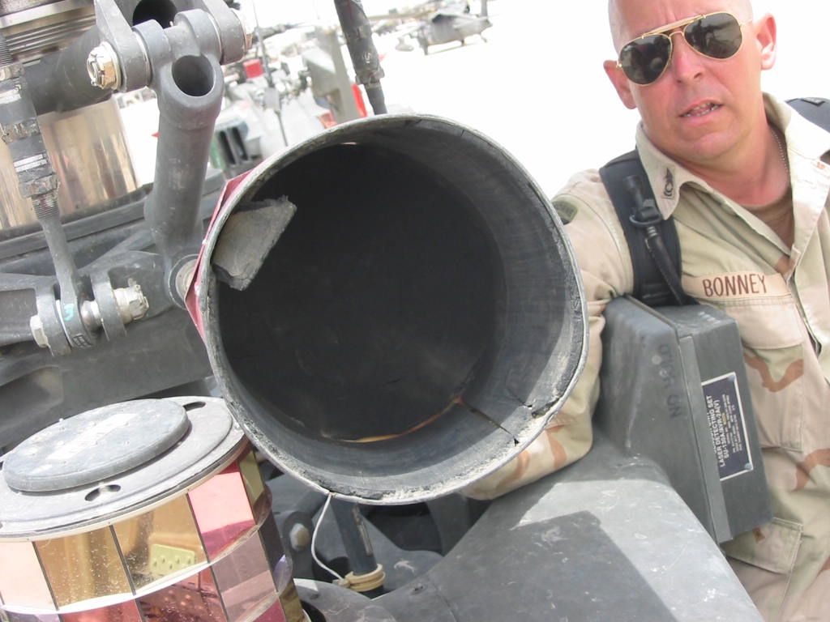

Figure 10: ALQ-144 Cover Figure 11: Inside of ALQ-144 Cover

- ULLS-A Floppy Drives: The ULLS-A floppy drives failed. The unit could use a floppy drive system 3 to 5 times before the disk was unreadable. The sand damaged the disk drives and the unit had to cannibalize other computer hardware to continue operating the ULLS-A system. The unit would prefer if all computer data transfers were done with no moving hardware parts. They recommended using the “Thumb” drives which interface with USB ports.

- Nitrogen Supply: The maintenance personnel need a “gang” unit to refill Nitrogen bottles. Nitrogen Bottles were quickly depleted and a gang unit would provide the needed large source of Nitrogen to replenish supplies.

- 30mm Chain Gun, Dust Abatement: To mitigate the effects of the harsh sand environment, maintenance personnel used a teflon lube (B25) on the round feed system. This lube tended to repel sand and prevented dirt build-up on critical components. Additionally, the 30mm weapon system was routinely cleaned with pressurized air to blow out dust and dirt. The application of Molbilium grease was minimized. The tensioner is critical to successful operation but was hard to access and clean. Additionally, the amount of tensioner cleaning was limited because it was restricted from getting wet. Maintenance personnel requested a dust cover be installed over the tensioner system in the right had FAB. A cover similar to the clear plastic cover over the round carrier on the left FAB is recommended (see figures 12 and 13). Finally, maintenance personnel requested an improvement to the 30mm gun cover. The current cover easily rips and is not durable. It needs improvement. See figure 14 for a representative rip in a gun cover.

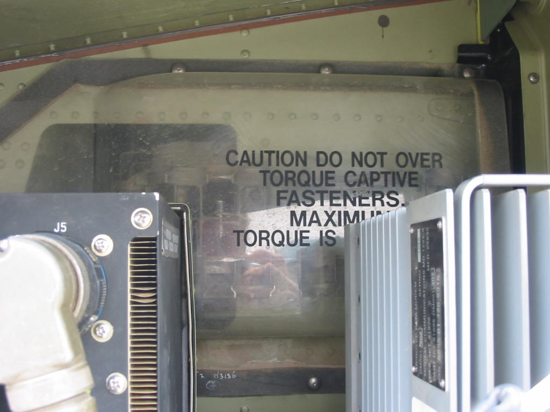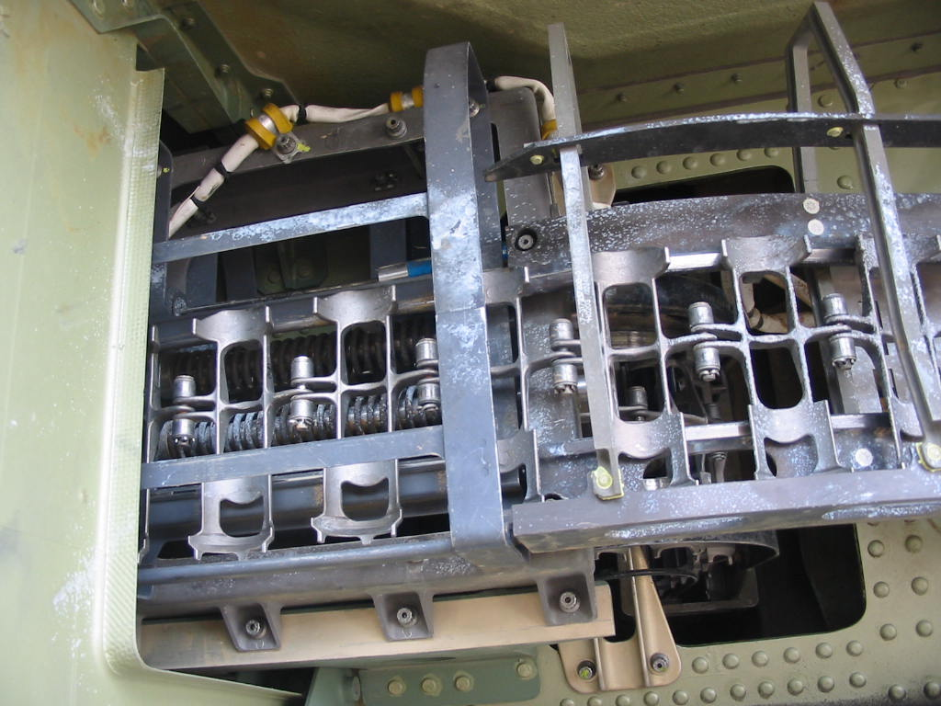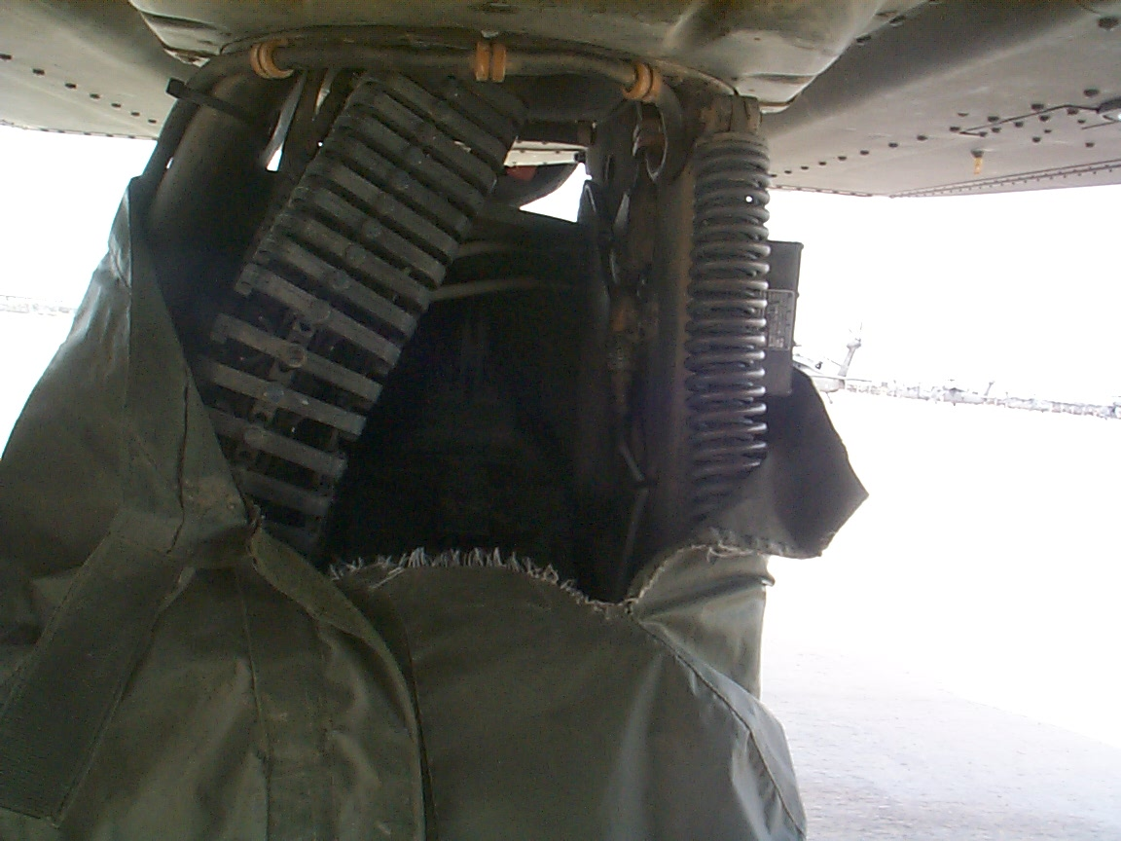

Figure 12, Right FAB Figure 13, Left FAB Figure 14, 30mm Cover

- Rotor Blade Tape: Maintenance personnel thought the blade tape worked great. This was not the same opinion of other aviation units. This unit thought it made a huge difference that they were not using the blade tape for the first time, but they used the same blade tape at home station (Fort Hood). The unit has used this blade tape for about 750 aircraft flight hours, which includes a National Training Center (NTC) rotation. The unit contributed a low spar debonding rate to the blade tape. As part of scheduled maintenance, the blade tape would be removed and reapplied during aircraft phase maintenance.

- Rotor Blade Dust Erosion Abatement: In addition to the rotor blade tape mentioned above in item 32, the unit continued to use manually applied paint on the rotor blades. They used a green apoxy polymine paint and a tan acrylic house exterior paint. Figure 15 shows the areas of the main rotor blade where the paint was applied.

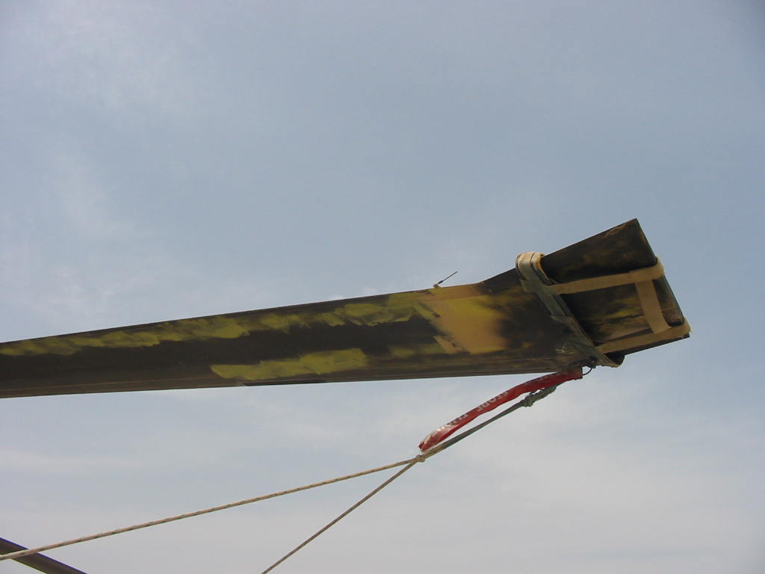

Figure 15

- Access Panel Damage: The maintenance access panel located under the front of the right FAB (the 5R47 panel) has a high rate of being damaged after firing the 30mm chain gun. Currently the access panel has one push type latch that is dislodged during firing of the 30mm (see figure 16). Additionally, the hinge holding the access panel becomes damaged once the panel is opened. Maintenance personnel would prefer a three screw system to secure the panel closed.

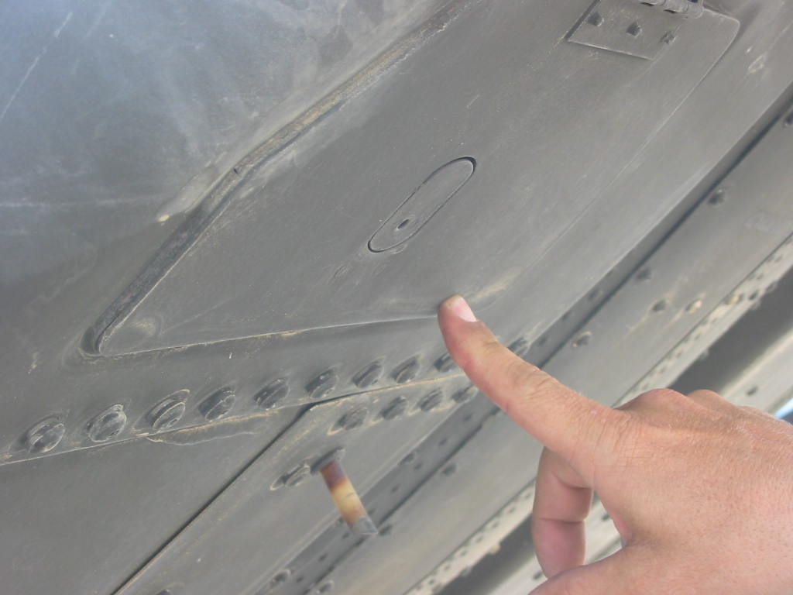

Figure 16

- Mooring Lug Damage: With the mooring lugs installed, damage is done to the uploader / downloader power port mounting plate. The mooring lugs tend to rotate, allowing the locking pin to contact and damage the mounting plate. Maintenance personnel in this unit modified the plate by cutting off a small portion to prevent damage (see Figure 17). Recommend reviewing the value of modifying the entire AH-64D fleet with a standard modification.

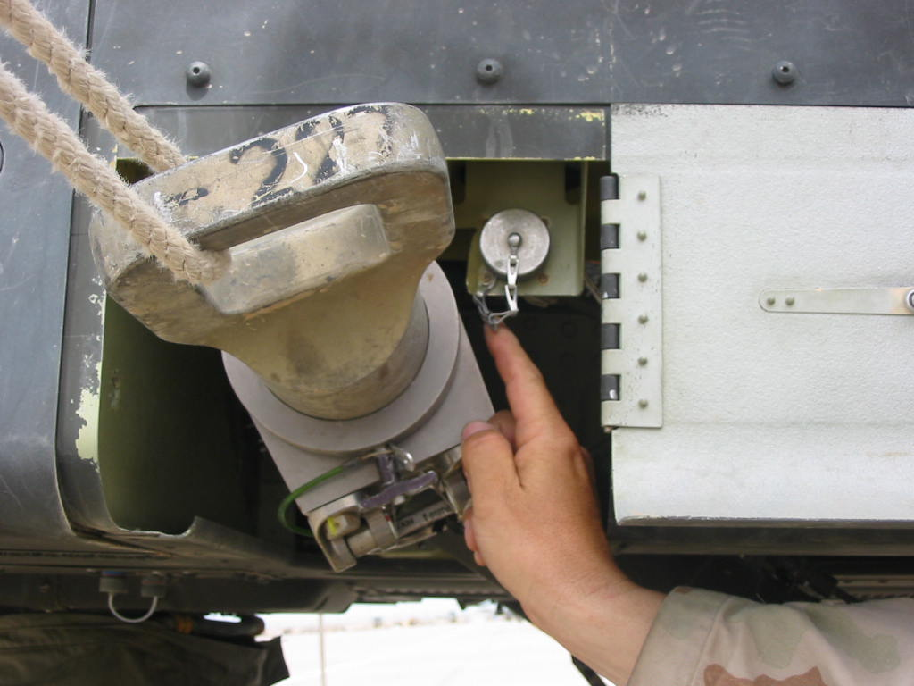

Figure 17

- Batwing Velcro: Pilots would prefer if the Batwing Velcro restraint straps were reversed. They would like the portion of the strap that is currently permanently attached to the batwing be modified to have the Velcro attachment. Accordingly, the portion of the strap that has Velcro, the pilots would like to have this end permanently attached to the batwing. See figure 18 for a picture of the current configuration.

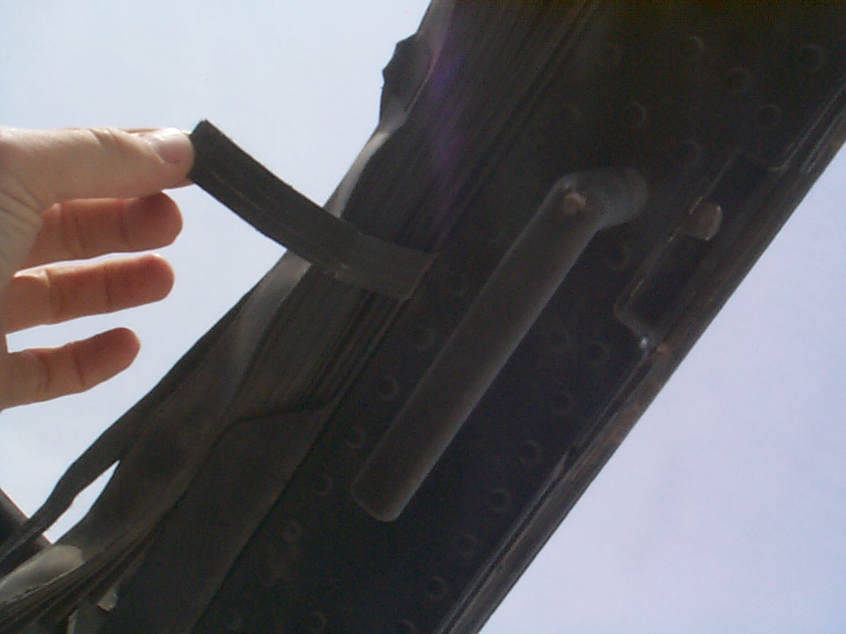

Figure 18

