SWA Science & Technology Assessment Team
(1 May 2003)

Activity: Material Assessment Debriefing, 1-82nd Aviation. This unit is a divisional helicopter battalion equipped with 12 OH-58D Kiowa Warriors.

Location: APOD, Kuwait International Airport

Participants:

MAJ Robert Johnston (AMC FAST)
Mr. Bill Andrews (AMC FAST)
MAJ Larry Homan (PEO AVN)
SSG Hardin (ASAALT)
LTC Chris Gahler (Battalion Commander)
CSM Weitus (Battalion Sergeant Major)
CW4 Jim Lattimore (Standardization Instructor Pilot)
CW3 Jim Hosmer (Safety Officer)
CW3 David Wilson (Maintenance Officer)

Results:

Below are comments made by the members of the 1-82nd Aviation. Comments are mostly in the order in which they were discussed.

- Mission Effectiveness: Overall, the OH-58D performed great. The unit was extremely satisfied with the aircraft’s performance in the harsh environment of Southwest Asia. LTC Gahler said “the KW is pretty darn reliable, had a good mission capable (MC) rate, was easy to maintain, cheap to keep in the air, and overall, the airframe was just GREAT!” Between 15 Mar to 15 April 2003, the unit flew 1037 hours. The unit accumulated an average of 40 hours of combat time per crewmember with a high time of 85 combat hours. With this high optempo, the unit still maintained a 99% MC rate and an 84% fully mission capable (FMC) rate (ALQ-144 was major contributor to down time, see item 5). Leading up to combat operations, the crews were flying double the minimum aircrew training program (ATP) flight time requirements of 14.5 hours. The unit’s flying hour program exceeded 7200 hours per year and this was required for preparing the many young aviators for combat operations.

- Battalion Task Organization: During their deployment to SWA, the unit pooled all the maintenance resources under the aviation unit maintenance company (AVUM). The maintainers and the aircraft were all pooled. The line companies only had to worry about mission execution. The battalion issued aircraft to the line units, as the mission required. This allowed the battalion to keep a very high optempo. LTC Gahler credited the overall mission readiness rate to this task organization. However, for peace time operations, he believes company commanders must be responsible for assigned aircraft maintenance and this type of task organization would not be appropriate.

- Gross Weight: Aircrews were asking many questions about the weight limitation and why it changes so often. They were operating at a max aircraft gross weight of 5500 lbs without any issues and understood the autorotational characteristics at this gross weight. They were then restricted to 5200 lbs. The Battalion commander and unit pilots preferred to be given the flexibility to fly at the higher gross weight while integrating risk mitigation into operations. This was iterated several times and displayed their level of frustration. The crews felt that they train at or near maximum gross weight routinely and are well prepared to go into combat at the high gross weight. With that in mind, the weight reduction program should focus on eliminating the ALQ-144 (item 5), eliminate ejector racks, eliminate ATAS (item 24), obtain lightweight hellfire launchers, replace 50-Cal (item 12) with GAU-19, upgrade MFD with lighter color displays, upgrade sight with low weight system and improved capability. Along the lines of weight reductions, the battalion commander noted that Army Aviation needs to look at the RAH-66 fielding strategy and compare what the Army envisions for the life expectancy of the OH-58D. If the OH-58D has a short lifespan, then continue with the COSSI weight reduction program and make the small improvements here and there. Or, if the Army sees a long life for the Kiowa Warrior, then Army Aviation needs to consider going bold with OH-58D upgrades with an OH-58X version. The X version would attack the issues noted below; taking advantage of the advanced lightweight and miniature technology available today. These pilots firmly believe in their mission and the OH-58D’s unique ability to accomplish it effectively as a low cost reliable system that is easily transportable.

- Interoperability with Ground Units: 1-82nd had a very close and effective relationship with the ground units it supported. However, target handovers from the ground to the air was difficult. The infantry soldiers perspective was too narrow. For example the infantry soldier would say shot the target 50 yards away from the stop sign on the road, but the OH-58D crew, with a much larger view of the terrain, could see multiple stop signs and did not know which sign to adjust fire from. The unit used hand held laser pointers to help positively confirm targets. Additionally, the enlisted tactical air control system (ETACS) was used to conduct target handovers. This system worked well as the ETACS had larger perspective of the battlefield and could better target the fires from the OH-58D.

- ALQ-144, IR Jammer: The crews do not want the ALQ-144. “Take it off.” All it was for them was a lead weight. It did not work anyway. All of the jammers had failures where the internal ball bearing would seize.

- Logistics: The unit felt “betrayed by the system as the rules changed when they went down range.” “The just in time logistics did not work, the parts pipeline was not there.” The parts requisition system changed when only aircraft on ground (AOG) parts were allowed to be sent forward. As a result, the unit heavily relied on their integral PLL. Unfortunately this was not sufficient. Fifteen days into the war, the unit was zero balance on many PLL items. Overall, 530 part requisitions were submitted, 35 of which were critical. They only received 5 or less than 1%.

- Engine Barrier Filter (EBF): “EBF was the Balls.” The unit noticed a significant improvement in engine reliability and decrease in engine performance degradation while operating in the extremely harsh desert environment. During their deployment to SWA, the unit had zero engine blending requirements which were routine prior to installing the EBF. For most of the time in SWA, the unit did not have the EBF cleaning system. As a field expedient, they would remove the EBF and shake the dirt out. This worked well and allowed the system to continue working for several days after each cleaning.

- Blade erosion: The different grades of dirt / gravel / sand was very corrosive to the main and tail rotor blades. The tail rotor blades had the most damage. L100 paint did not work on the rotors. They also used an old lot of blade tape, but this did not work either. The best solution to prevent blade erosion was to use a type of Sherwin Williams’s thick black paint. They could not remember the actual type of paint.

- RMS & Moving Map: Pilots said this was a good improvement and that they liked the moving map display. One issue; the memory card on the MDU only holds 40 MB of data. This limits the mission planning data and the number of maps one can up load. This was particular problem when the unit was operating in a “fold” of the military grid reference system (MGRS). The crews would have to load whole maps of adjoining map grid zones (ie. 38R & 38S) when operating on both map sets.

- Aviation Mission Planning System (AMPS): AMPS had limited functionality. Pilots did not like it at all. The only thing AMPS was used for was data entry. They said Falcon View worked better as a planning system. This windows based AMPS was not intuitive, and they preferred the older version. The new version was confusing to use. The mission analysis portion of AMPS was not used. The aviators would like to see all the different types of planning systems compatible such as AMPS, Falcon View, C2PC, MCS Light when viewing graphics and updating aircraft cartridges. 1-82nd did not have ADOCS which was used to develop the Air Tasking Order (ATO). ADOCS was compatible with Falcon View.

- RMS symbology: Brighten the heading tape. Under certain conditions, the heading tape was washed out by background video and was not readable.

- Weapon Systems: The 50-Cal was not used due to reliability. Everytime the unit attempted to use the gun, it failed. The aircraft were loaded instead with Flachette 2.75-inch rockets. Six aircraft were loaded in a rocket only configuration with Flachette and HE rounds. The other six aircraft were loaded mixed with rocket and Hellfire. This unit shot C model Hellfires. However, the crewmembers would have preferred the M model Hellfire with a HE warhead. The crews did not like the idea of a precision rocket since they use rockets for suppression fire, not for precision engagements. Finally, the annual STRAC ammunition allocation is not sufficient to maintain pilot gunnery proficiency.

- Laser Range Finder / Designator: The unit needs a system that can test the laser without removing the laser from the aircraft. Some of the lasers were intermittent, but without an onboard system, the unit could not easily determine this.

- Airborne Laser Tracker (ALT): The unit wants a laser tracker so it could have a pointing capability. They want this capability for ground to air, air to ground, and air to air day or night pointing capability. The unit resorted to hand held green lasers and aircraft Aim II IR lasers to direct fire. The photos below show the mounting of the Aim II laser.
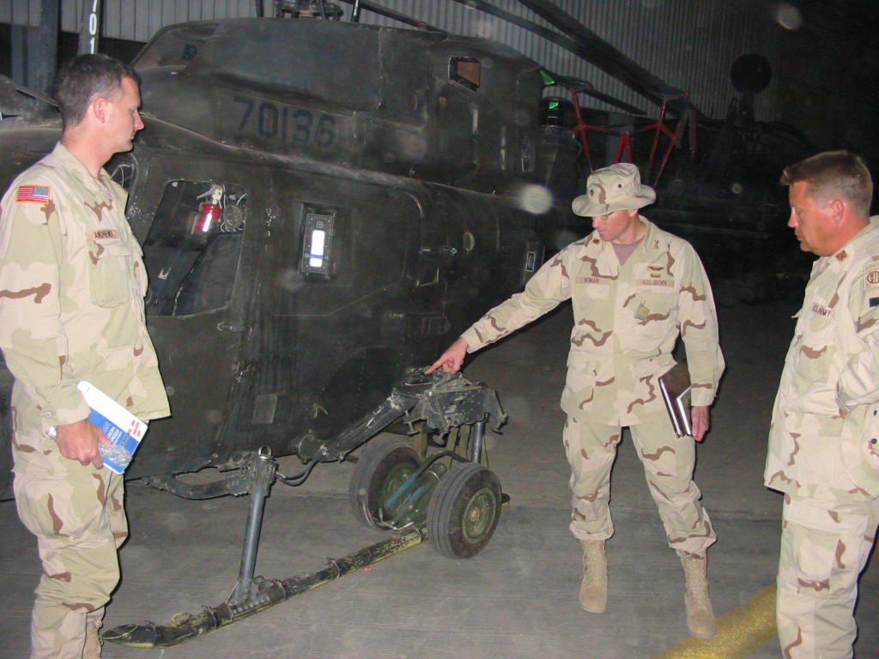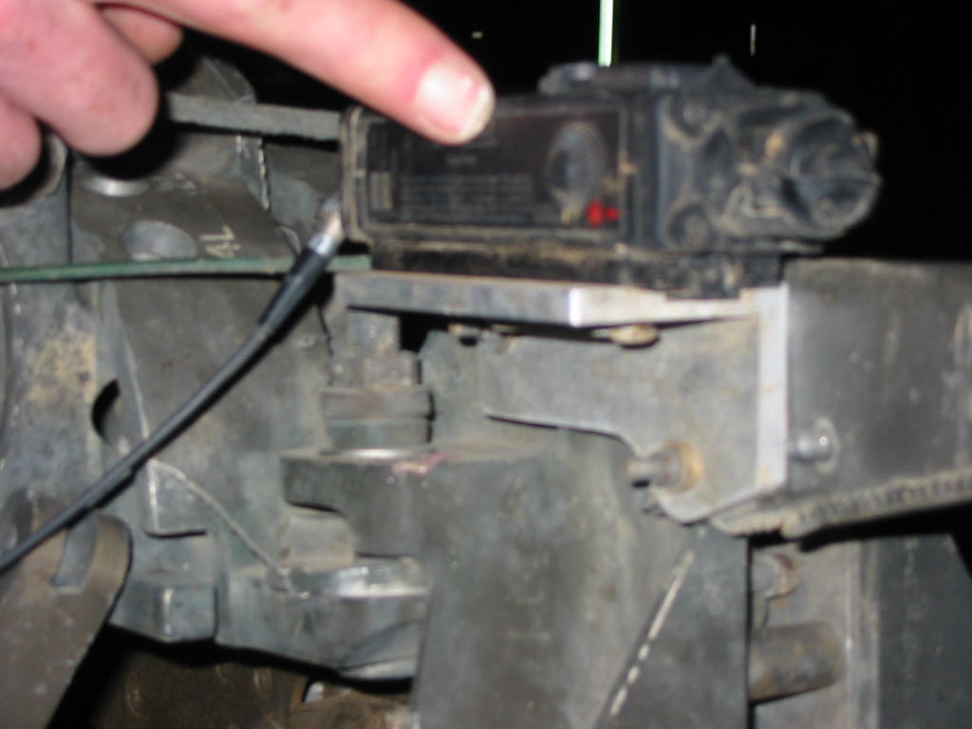

- AVTR: “Good concept, Poor execution.” Typically, tapes would not unthread when you wanted to remove the tape. It would be better if the recording device had no moving parts such as flash card technology. The video recording format should be compatible with most other systems using USB and JPEG type files.

- Tactics: Once the ADA threat was suppressed, the unit flew higher to avoid small arms. Altitudes varied from 500 to 800 feet. Airspace was pre-coordinated for up to 2000 feet. They credited their survivability and the lack of battle damage on the unit’s aircraft due to flying higher. Additionally, they used a methodical approach to entering cities and would not fly over the city until it had been swept by friendly forces, either air or ground.

- VIXL: This system is better than Photo-T because it is more intuitive to use. However, the ground units that 1-82nd supported could not receive the images, and the quality of the image was not clear. The unit could only send this data to other OH-58Ds but this capability was never utilized.

- Improved Data Modem (IDM): Crews did not like the IDM. The improved IDM system was hard to use and was not intuitive. There did not seem to be standardization between other systems such as AFATDS. The crews preferred to use voice because it was quicker and less confusing. Overall, the unit fired “ZERO” IDM missions.

- Maintenance Cartridge: The unit would like to have a data cartridge that would give readouts for engine torque, temperature, and other related flight data. Currently they have access to a conglomerate of data, but it is sometimes unrelated. For instance, the unit had a suspected engine overtorque where the data retrieved provided an engine torque reading of 119% and 4 seconds. However, 4 seconds was the duration 119% torque. If this data were related this would have indicated an overtorque. However, the data showed max torque of 119% and the maximum time above 103% of 4 seconds. This was not an overtorque condition, but the unit did not have quick access to decipher the data and the aircraft was grounded for a period of time. This removed a combat asset from the fight unnecessarily.

- Performance Planning Card (PPC): Aircraft performance planning for the R3 engine is too complicated. Engine Torque Factors (ETF) of 1.0 and 0.95 cause excessive manual calculations to be made. The pilots recommend referring to all engines as 0.95 and do away with all the calculations. Better yet the OH-58D performance planning chapter in the operators manual should be updated to emulate the UH-60 performance planning chapter. The UH-60 operator’s manual is able to incorporate a range of ETF with no manual calculations performed by the operator.

- Airworthiness Release (AWR): The crews did not like the additional information contained in the AWR or the number of AWRs. For an R3 engine, the pilots are required to reference up to 4 different AWRs and use along with data obtained within the operator’s manual. Pilots recommend getting rid of AWRs in back of logbook and incorporate into operator’s manual.

- Crew Seats: Pilots prefer the old seat as compared to the SEP seat which is not durable enough. The foam moves around too much. The cloth is not durable and comes apart. The seat holds heat and moisture. The seat works well and is great to use when it is new, but after some usage, it becomes very uncomfortable.

- ODA: The ODA is a good system. However, the intensity is too high with moon illumination less than 50%. Additionally, the system is not compatible with new generation 3 goggles. The focus knob is too big and should be less bulky.

- Air to Air Stinger (ATAS): “Get rid of ATAS.” The pilots don’t want the ATAS and do not think it is part of the OH-58D mission. They would rather lose the ATAS and the associated weight and increase other weapon loads such as Hellfire or rockets.

- Refueling Port: The unit wants a standard refuel port for all aircraft. They want a closed circuit refuel (CCR) accessible port.

- Flyaway Gear: The unit would like a piece of flyaway gear to cover cockpit doors and wing stores. Since the unit routinely flew without doors attached, they did not have anything to cover the doors when not flying. A significant amount of sand and dirt entered the cockpit. As for the wing stores the unit used body bags to cover the wing stores. This served to protect the systems from the dirt and sand. The system would have worked even better if a “flyaway bag” was made similar to the body bag but had zippers to zip from opposite ends of the bag.

- Navigation Aids (NAVAID): The unit would like a NAVAID installed on the aircraft to give them the capability to perform a field recovery from an emergency inadvertent entry into IMC conditions. NAVAIDS mentioned included TACAN.

- Non-Line of sight (NLOS) Radio: the unit wants NLOS radios. Typically, they operated 40 miles away from operations centers and this proved to be a challenge with their standard line of sight systems. The FM radio did not work at that range.

- Detachable Keyboard: The pilots would like a detachable type keyboard. The current interface for data entry is cumbersome and frequently interferes with flight controls.

- Universal Extraction System: The OH-58D needs this. “Kiowa can do the self extraction mission” and in many cases during OIF, the closest CSAR was 3 hours away. For a successful crew recovery, other OH-58Ds were a downed pilot’s only recourse. Pictures were taken showing a system developed by the unit. The unit would like clevis rings attached to the side of the aircraft to complete the system they developed. Two clevis rings would be attached on the side of the fuselage just forward and aft of the extracted pilot. The photo on the left shows the configuration for pilot extraction. The photo on the right shows the extraction equipment stowed in a bag that is located just inside the cockpit and behind the pilots head. Additionally, non-slip tape was applied to the aircraft landing gear where an extracted pilot would put his feet.

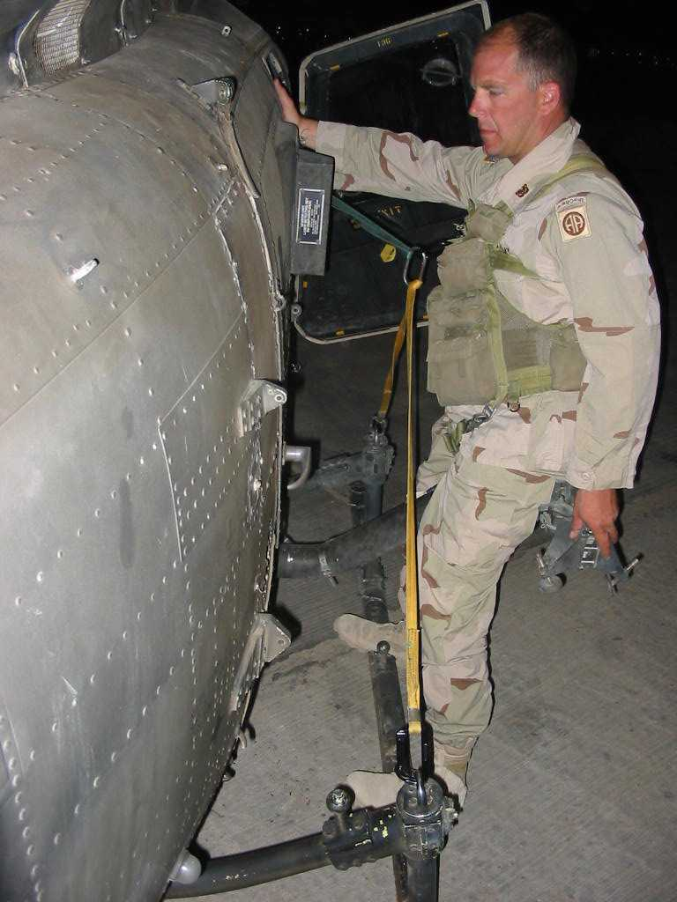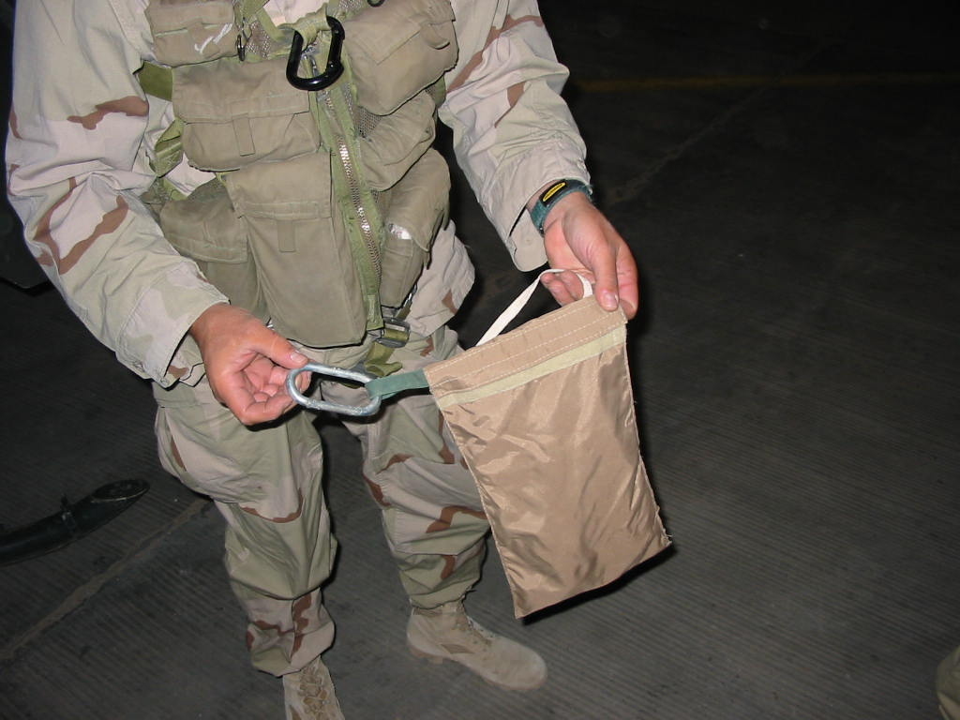

- M4 cockpit stowage: The unit developed a well like method to stow two M4s in flight. They were located on the black dashboard above the instrument panel and provided quick and easy access. The weapons were secured with Velcro and straps in front of each pilot (see picture below).

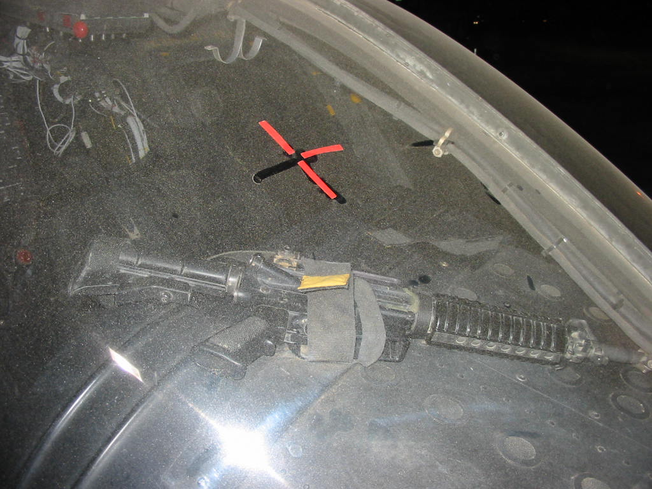

- Survival Kit: The OH-58D needs a survival kit designed for this aircraft which takes into account weight, space available, and crew access. Essential items according to these pilots are kevlar helmet, weapon, sleep bag, and chemical protection. The Army needs to consider access to a kit during post crash scenarios when designing RAH-66. An example to consider is over water flight. Survival equipment will do the crews no use if crews cannot get to the kit before it sinks.

- Airsave aviation life support equipment: Overall, the system was too bulky and the crews did not like it. Only small aviators were able to use it at all because of the limited space in the OH-58D cockpit. Additionally, the system was very hard to put on and should have some sort of quick release system on the legs. On the positive side, crews very much liked the body armor it provided and the ability to move pockets around.

- Cockpit Airbags (CAB): Aircrews do not want if it adds weight.

- Grenadier Brat: The unit was unable to get the system to operate and did not use it.

- GPS reception: Between 28 Mar and 10 Apr, many aircraft had trouble initializing their embedded GPS INS (EGI) systems. The crews reported that this was not isolated to the OH-58D, but had heard rumors that the AH-64 had similar problems. It may have been a satellite reception issue. If so, the battalion commander said he would like to see some sort of message issued to the units so they can be aware of the satellite condition. This data is available since in FAA airspace, NOTAMS are issued in CONUS when satellite data is insufficient to execute a GPS based instrument approach.

